Problem Statement
Operations team requires quick health summary.
Objective
Build a script that reports:
- CPU usage
- Memory usage
- Disk usage
- Top processes
- Active network connections
Solution
- Created a new directory and created a new file inside that “check.sh”
- Inside that file based on the objective I have written code with linux command using script shell
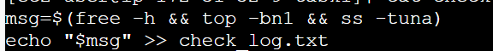
Figure 1:check.sh
- Then executed the code by running bash check.sh
- Then if we view the content of the check_log.sh file

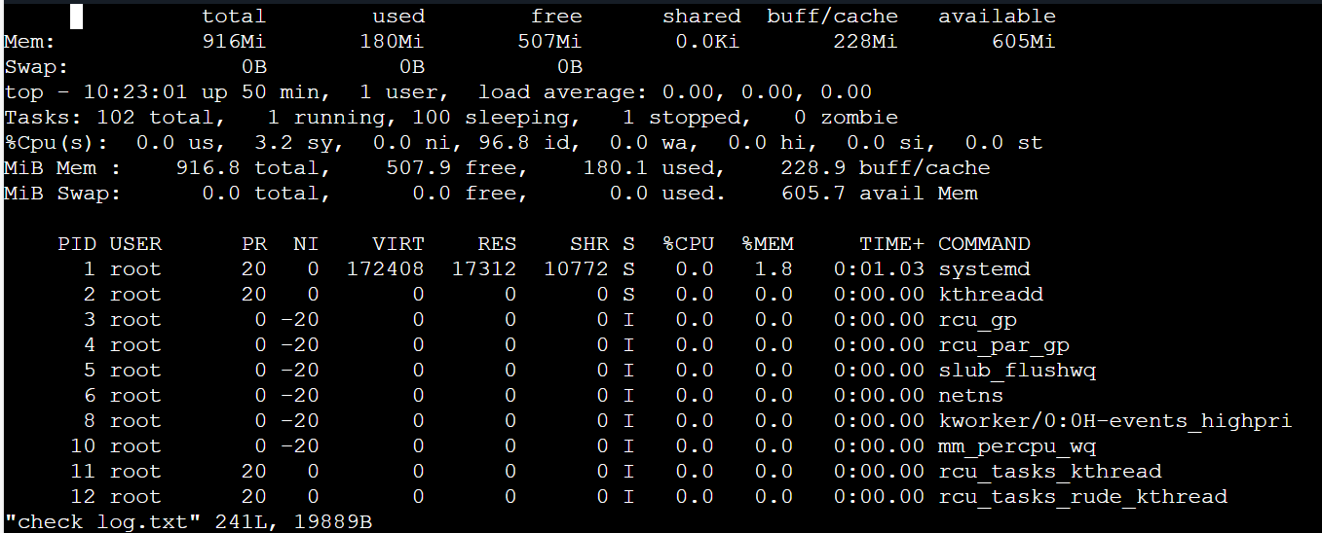
Figure 2:output

